**Project Design Phase-II**

**Data Flow Diagram & User Stories**

|  |  |
| --- | --- |
| Date | 26.06.2025 |
| Team ID | SWUID20240036329 |
| Project Name | Ora Social Media App |
| Maximum Marks | 4 Marks |

**Data Flow Diagrams:**

A **Data Flow Diagram (DFD)** for ORA illustrates how data moves through the social media platform. It represents how users interact with the system, including authentication, post creation, interactions (like, comment, save), and profile management.

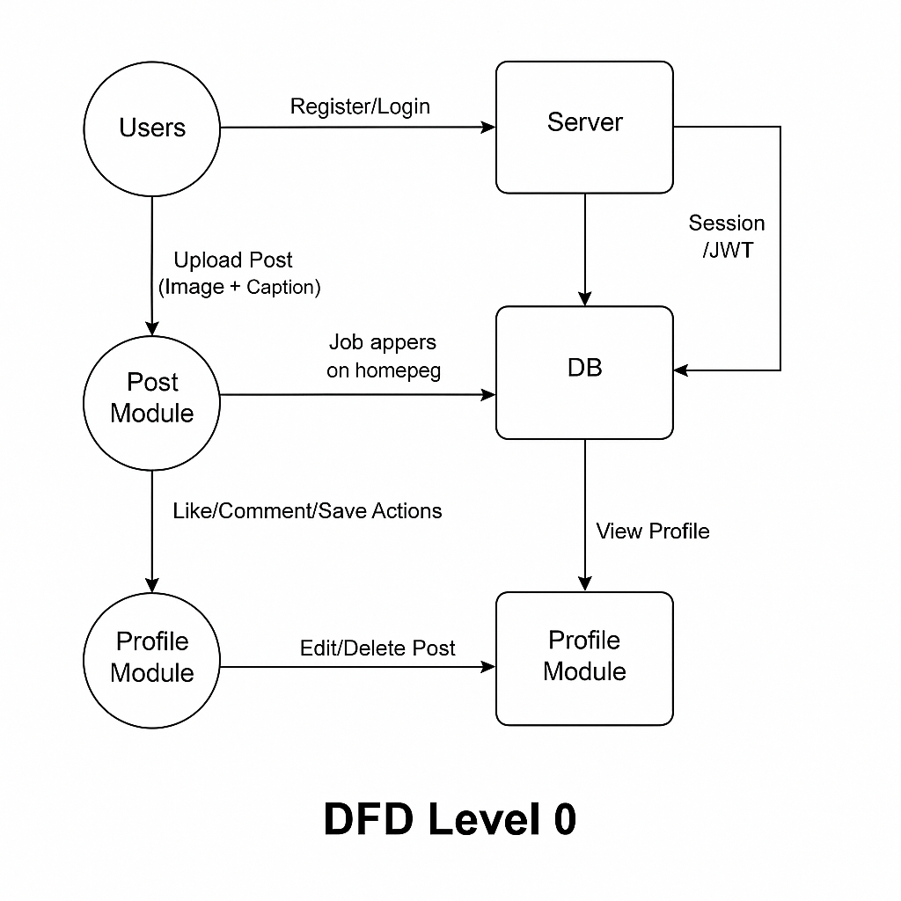

**User Stories**

**User Story Table – Ora**

|  |  |  |  |  |  |
| --- | --- | --- | --- | --- | --- |
| **User Type** | **Functional Requirement (Epic)** | **User Story / Task** | **Acceptance Criteria** | **Priority** | **Release** |
| User | Authentication | As a user, I can register and log in securely. | Redirected to feed after successful login. | High | Sprint-1 |
| User | Post Upload | As a user, I can upload image posts with captions. | Post appears in feed and profile. | High | Sprint-2 |
| User | Feed View | As a user, I can view posts uploaded by others. | All posts load in feed with latest first. | High | Sprint-2 |
| User | Like/Save | As a user, I can like and save posts. | Like/save reflected instantly and saved in DB. | Medium | Sprint-3 |
| User | Comment System | As a user, I can comment on posts and view all comments. | Comments display under the post in real time. | High | Sprint-3 |
| User | Profile Management | As a user, I can view and manage my profile and posts. | Profile shows user info and all posts uploaded by them. | Medium | Sprint-4 |